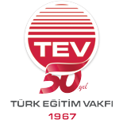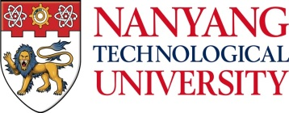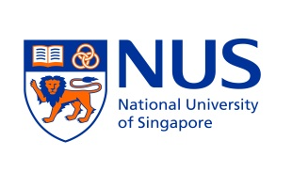

TEV – SINGA
FULLY FUNDED PHD PROGRAMME 2018–2019
www.tev.org.tr

TEV-SINGA scholarship will be offered to outstanding candidates to undertake a PhD degree in the areas of Key Science, Engineering, and Biomedical Sciences at one of the following institutions in Singapore: A*STAR (The Agency for Science, Technology and Research), NTU (Nanyang Technological University), NUS (National University of Singapore) or SUTD (Singapore University of Technology and Design). Further details about these institutions can be found at their websites; www.a-star.edu.sg - www.ntu.edu.sg - www.nus.edu.sg – www.sutd.edu.sg - www.singa.a-star.edu.sg

AREA OF PHD STUDIES
- Biomedical Sciences
- Biochemistry / Chemistry / Pharmaceutics
- Immunology / Microbiology / Molecular Virology / Cell / Developmental Biology
- Bioinformatics / Systems Biology
- Biotechnology
- Neuroscience
- Veterinary Science
- Biostatistics / Epidemiology

- Physical Sciences and Engineering
- Aerospace Engineering
- Electrical Engineering / Computer Sciences
- Chemistry Engineering / Chemistry
- Mechanical engineering
- Civil Engineering
- Industrial & Systems Engineering
- Physics Engineering / Applied Physics
- Materials Sciences & Engineering
- Engineering & Technology Management
- Bioengineering
- Mathematics

PhD Scholarship will be offered for four years. Doctoral studies can be undertaken in any of the following institutions: A*STAR, NTU, NUS or SUTD. Details can be found below.

ELIGIBILITY CRITERIA:
- To be a Turkish citizen and not to be over age 30.
- To have a BA and/or MS degree in one of the above areas from a university located in Turkey (Candidates who are currently in their final years of BA degrees can apply as well)
- To have a minimum GPA of 3.00 out of 4.00 or 75 out of 100.
- To have a proficient level of English (A TOEFL score of ≥80 or IELTS score of ≥6)

APPLICATION
Candidates who meet the above criteria can download application forms on our website www.tev.org.tr or obtain one at any of the TEV Branches. Deadline for application is 29th December 2016.

Further details can be found at the following address.

APPLICATION ADDRESS:
Türk Eğitim Vakfı, Eğitim Müdürlüğü, Büyükdere Cad. No:111 Kat:8
34349/Gayrettepe/İSTANBUL
Tel: 0212-318 68 03 Fax: 0212–272 62 17
E-mail: yurtdisiburs@tev.org.tr

